Saving your customized filter templates enables the user to include/exclude individual and repeating strings from the translation project. The filter for JSON files for example has these advanced customization options available. You can ctreate your template and even set it as the default one for all feature projects.

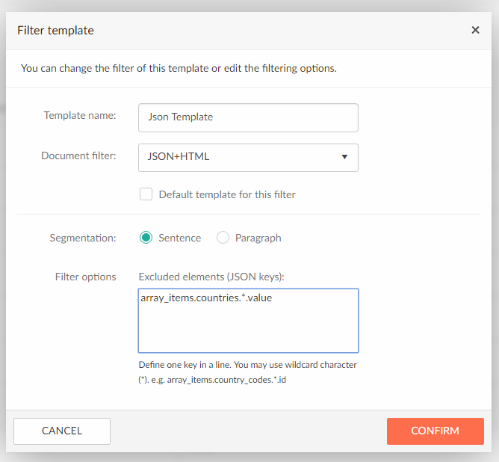

How to access the filter options

To access the filter templates and create a new one, navigate from the user menu in the right corner to **Filter settings**. On this page you will be able to add new custom templates or edit existing ones.

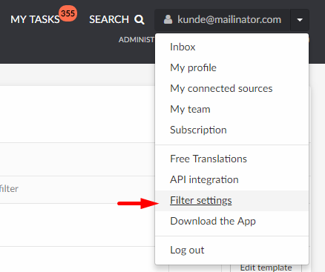

After you’ve created a new filter template, navigate back to your Translation Projects.

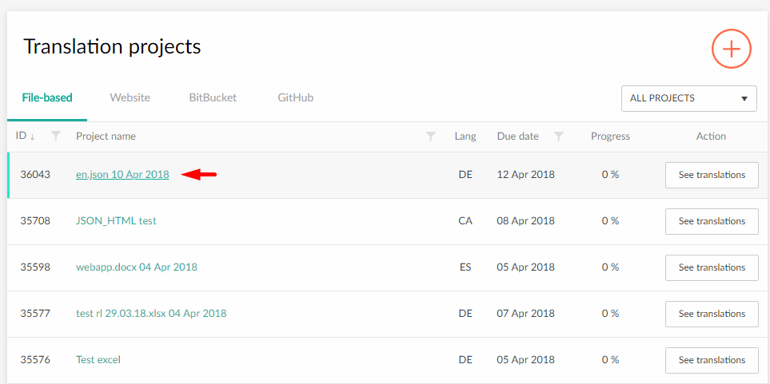

* Open the project details by clicking on the project name.
* Click on the “Source files” tab
* For each file, there is a dropdown menu that contains all your filter templates. Select one to apply to the file.

After a few moments, you will receive a notification on the page when the filter is successfully applied.

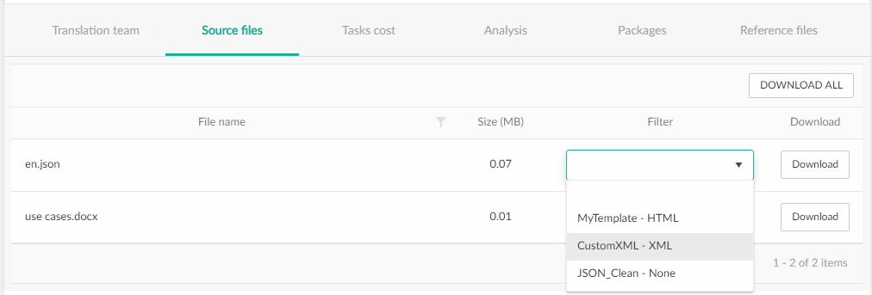

Use examples:

Adjusting filter settings can provide a much cleaner workspace for translators. Not everything that is being extracted from a CMS in the form of .json or .xml is necessary for translation. These files can include words, phrases and strings that are irrelevant for your translation project. Excluding these strings from your translation project will result in a much more „User-friendly“ and „readable“ translation project with a smaller wordcount.